China Customs Enforcement of Intellectual Property Rights (IPR) in 2008

General Administration of Customs of the People’s Republic of China (GACC)

Introduction

In 2008, China Customs administrations nationwide, in accordance with the major decision of the CPC Central Committee and the State Council on construction of an innovative country and the unified deployment for the implementation of the Outline of the National Intellectual Property Strategy, gave full play to the major function of Customs in national intellectual property rights (IPR) protection system and to the function of border enforcement agencies, by which the Customs IPR protection has been further strengthened. +
In 2008, China’s total import and export value reached USD 2.56 trillion; import and export freight volume supervised by Customs exceeded 2.4 billion tons; the number of declaration forms reviewed by Customs exceeded 49.07 million; 240 million entry-exit postal parcels and express items were inspected and released by Customs; and 360 million entry-exit passengers were supervised by Customs. Facing with the increasing workload of supervision, it’s a major task for China Customs to enhance the effectiveness of enforcement against exports and imports infringing IPR while ensuring the smooth clearance of the entry-exit goods and persons. In order to settle the conflict between convenient legal import and export and effective IPR protection, the Customs at all levels took measures to comprehensively strengthen enforcement ability of Customs in IPR protection and effectively safeguard the lawful rights and interests of right holders in entry and exit links through risk analysis techniques, improving cooperation with IPR holders, strengthening the training for enforcement officers at ports or otherwise.

I. Overview of Customs IPR Enforcement in 2008

(I) Protection measures taken by Customs and sharp increase in batches of infringing goods detained by Customs
Customs protection measure refers to measure of customs clearance suspension taken by Customs aimed at intellectual property rights (IPR) protection in accordance with the Regulations of the People’s Republic of China on Customs Protection of Intellectual Property Rights (hereinafter referred to as the Regulations on Customs Protection of Intelligent Property Rights) prior to detaining the exports and imports and entry-exit goods. For goods or articles suspended in customs clearance, Customs should detain suspected infringing goods or articles confirmed by IPR holders; and Customs should release those without suspicion of infringement confirmed by IPR holders or not required by IPR holders to be detained by Customs. Therefore, IPR protection measures taken by Customs are the precondition of seizing infringing exports and imports. In 2008, Customs nationwide took 13,140 times IPR protection measures, increasing by 54.6% compared with 2007. Customs strengthened their efforts in taking IPR protection measures, which led to substantial increase in batches of suspected infringing goods detained by Customs: 11,135 batches of suspected goods in total were detained by China Customs in 2008, increasing by 49.3% compared with 2007 (see Table 1).
Table 1 Condition of Protection Measures Taken in 2008

Year | Protection Measures Taken | YoY Rate | Batches Detained | YoY Rate
2007 | 8,498 |  | 7,456
2008 | 1,3140 | +54.6% | 11,135 | +49.3%
Note: unit for protection measures taken: time; unit for goods detained: batch

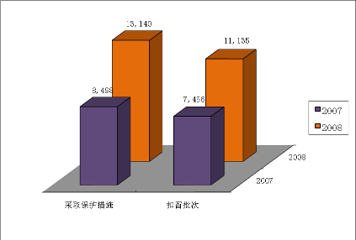
Protection measures taken
Batches detained

In 2008, Customs detained 645,182,937 suspected infringing goods, increasing by 93.5% compared with 2007. The value of infringing goods was RMB 294,802,157, decreasing by 32.8% compared with 2007 (see Table 2).

Table 2 Condition of Suspected Infringing Goods Detained by Customs in 2008

Year | Quantity of Suspected Infringing Goods | YoY Rate | Value | YoY Rate
2007 | 333,498,249 |  | 438,855,566
2008 | 645,182,937 | 93.5% | 294,802,157 | -32.8%
Note: unit for the quantity of suspected infringing goods: piece/pair; value unit: RMB

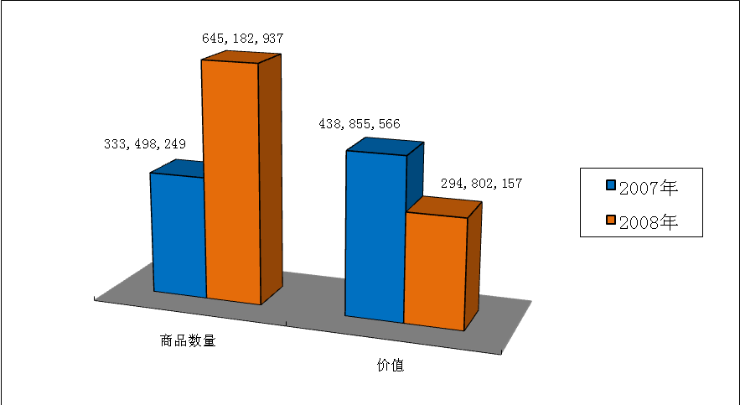
Quantity of goods
Value

(II) Export link infringement in overwhelming majority
Although there is no requirement of taking border IPR protection measures in export link by each member in the Agreement on Trade-Related Aspects of Intellectual Property Rights, Chinese government has authorized China Customs to take measures to protect the IPR in both import and export links since 1994 through legislation based on safeguarding fair competition in global trading order. China Customs, in accordance with the law of the State, took strict supervision measures in export link and seized large numbers of export goods infringing the IPR.
In 2008, China Customs seized 644,949,820 suspected infringing goods in export link with the value of RMB 291,712,997, accounting for 99.96% and 98.95% respectively; and seized 233,117 pieces of infringing goods in import link with the value of RMB 3,089,160, accounting for 0.04% and 1.05% respectively (see Table 3).

Table 3 Statistics of infringing Exports and Imports Seized in 2008
Note: unit for goods: piece/pair; value unit: RMB
 | Quantity of Goods | Proportion | Value | Proportion
Import | 233,117 | 0.04% | 3,089,160 | 1.05%
Export | 644,949,820 | 99.96% | 291,712,997 | 98.95%

(III) Infringement upon trademark rights in majority
In 2008, suspected infringing goods detained by China Customs were mainly related to exclusive right to use trademark, copyrights, copyright-associated rights, patent rights, and Olympic symbols (see Table 4), but the goods suspected of infringing exclusive right to use trademark detained by Customs were in majority. The goods suspected of infringing exclusive right to use trademark accounted for 99.63% of total suspected infringing goods detained by Customs.
Table 4 Statistics of IPR Types Involved in Infringing Goods in 2008

IP Type | Quantity of Goods | Proportion | Value | Proportion
Exclusive Right to Use Trademark | 642,801,664 | 99.63% | 277,175,492 | 94.02%
Copyright | 50,647 | Less than 1% | 847,355 | Less than 1%
Patent | 1,880,975 | Less than 1% | 12,948,550 | 4.39%
Exclusive Right of Olympic Symbol | 449,651 | Less than 1% | 3,830,760 | 1.30%
Note: (I) unit for quantity of infringing goods: piece/pair; (II) copyright includes copyright-associated right

(IV) Infringing goods were mainly consumer goods
In 2008, infringing goods seized by China Customs were mainly consumer goods, including clothing, shoes, bags and leatherware, communication devices, storage medium, and tobacco. (see Table 5)

Table 5 Category of Infringing Goods Detained by Customs in 2008
Note: unit for the quantity of goods: piece/pair; value unit: RMB
Goods Category | Quantity of Goods | Proportion | Value | Proportion
Clothing | 1,613,877 | Less than 1% | 22,276,084 | 8%
Shoes | 888,685 | Less than 1% | 17,145,646 | 6%
Caps and Hats | 331,962 | Less than 1% | 4,072,076 | Less than 1%
Bags and Leatherware | 380,710 | Less than 1% | 6,100,531 | 2%
Cosmetics and Care Products | 5,505,752 | Less than 1% | 21,200,760 | 7%
Other Light Industrial Products | 27,359,492 | 4% | 28,786,062 | 10%
Autos and Motorcycles | 998,389 | Less than 1% | 11,737,826 | 4%
Watches | 225,948 | Less than 1% | 4,867,393 | 2%
Toys and Games | 374,100 | Less than 1% | 2,243,334 | Less than 1%
Communication Devices | 1,093,602 | Less than 1% | 22,775,068 | 8%
Storage Medium | 456,192 | Less than 1% | 6,832,480 | 2%
Other Mechanical and Electrical Products | 3,800,796 | Less than 1% | 16,398,522 | 6%
Hardware and Machinery | 1,136,291 | Less than 1% | 9,258,069 | 3%
Jewelry | 94,165 | Less than 1% | 1,019,940 | Less than 1%
Gymnastic Apparatus | 148,630 | Less than 1% | 1,628,809 | Less than 1%
Medicine | 230,762 | Less than 1% | 7,247,302 | 2%
Food and Drink | 1,563,553 | Less than 1% | 1,910,929 | Less than 1%
Tobacco | 562,765,960 | 87% | 83,726,791 | 28%
Others | 36,214,071 | 6% | 25,574,535 | 9%

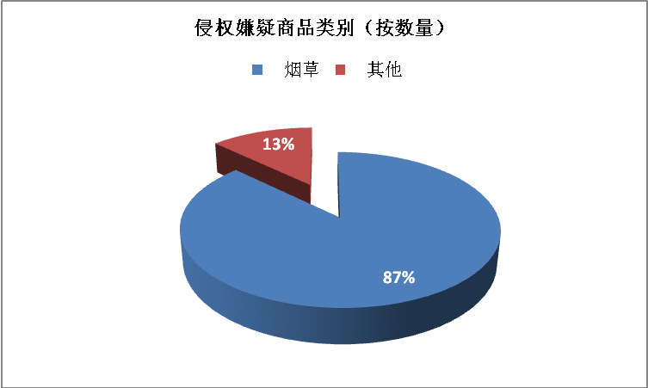
Category of suspected infringing goods (by quantity)
Tobacco
Others

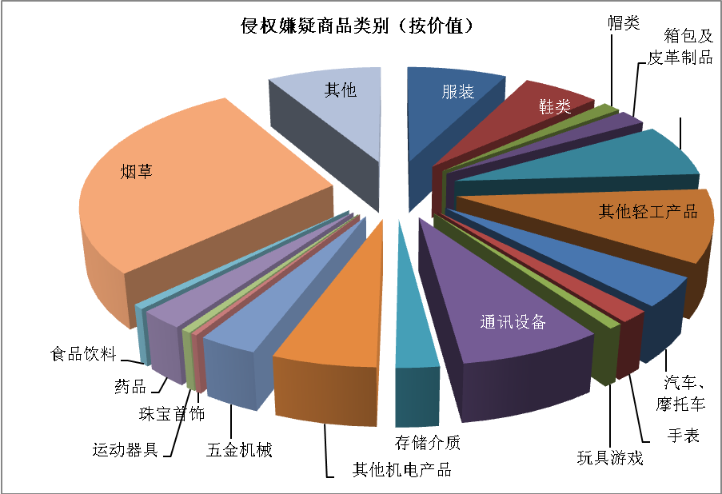
Toys and Games
Autos and Motorcycles
Tobacco
Category of suspected infringing goods (by value)
Watches
Caps and Hats
Bags and Leatherware
Food and Drink
Medicine
Jewelry
Other Mechanical and Electrical Products
Hardware and Machinery
Gymnastic Apparatus
Others
Shoes
Storage Medium
Communication Devices
Clothing
Other Light Industrial Products

(V) Sea transportation and post were main transportation channels for infringing goods
In 2008, China Customs took IPR protection measures in many transportation channels, such as transportation by sea, air, train, truck, post, express delivery, and passenger carriage.
Batches of detained goods transported by post accounted for majority (67%) of total batches of goods detained by Customs (see Table 6). However, detained goods transported by sea accounted for the largest proportion of total infringing goods detained by Customs whether in quantity (98% (see Table 7)) or value (82% (see Table 8)).

Table 6 Mode of Transport for Infringing Goods (by Detained Batches)
Mode of Transport | By Post | By Express Delivery | By Sea | By Air | By Truck | By Train | Others
Batches | 7,432 | 1,447 | 1,140 | 345 | 185 | 125 | 466
Proportion | 67% | 13% | 10% | 3% | 2% | 1% | 4%
Note: (I) batch unit: batch; (II) “Others”: passenger carriage; bonded zone, bonded warehouse, etc.

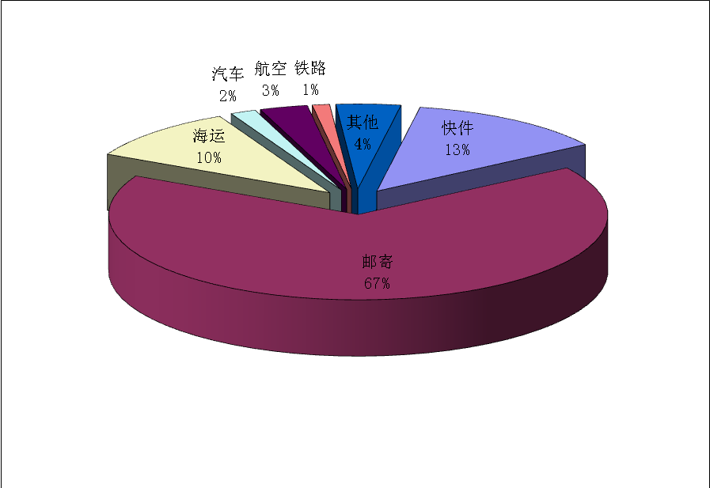
By air
Others
By train
By post
By sea
By truck
By express delivery

Table 7 Mode of Transport for Infringing Goods (by Quantity of Goods)

Mode of Transport | By Post | By Express Delivery | By Sea | By Air | By Truck | By Train | Others
Quantity of Goods | 2,735,949 | 1,395,178 | 633,748,093 | 432,378 | 6,607,723 | 141,728 | 121,888
Proportion | 0.4% | 0.2% | 98% | 0.1% | 1% | 0.1% | 0.1%
Note: (I) unit for the quantity of goods: piece/pair; (II) “Others”: passenger carriage; bonded zone, bonded warehouse, etc.

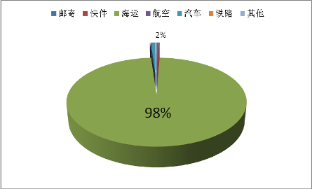
By train
By air
By sea
By express delivery
deliveryexpress
By postpost
Others
By truck

Table 8 Mode of Transport for Infringing Goods (by Value)

Mode of Transport | By Post | By Express Delivery | By Sea | By Air | By Truck | By Train | Others
Value | 21,229,724 | 4,858,738 | 243,215,557 | 13,515,215 | 6,912,840 | 2,687,656 | 2,382,427
Proportion | 7% | 2% | 82% | 5% | 2% | 1% | 1%
Note: (I) value unit: RMB; (II) “Others”: passenger carriage; bonded zone, bonded warehouse, etc.

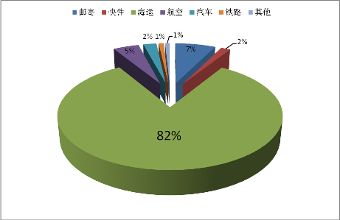
By train
By air
By sea
By express delivery
deliveryexpress
By post
Others
By truck

(VI) Major objects of infringement trade were the U.S. and European countries
In 2008, Customs seized suspected infringing goods relating to 138 countries and regions overseas, and the most batches of goods detained were from the following 10 countries and regions: the U.S., Britain, France, Japan, Hong Kong Special Administrative Region of China, Australia, Sweden, Italy, Netherlands and Macau Special Administrative Region of China (see Table 9). Among them, those from only the U.S. and Britain accounted for 50% of total infringing goods detained by Customs.

Table 9 Major Trading Countries (Regions) of Infringing Goods Detained by Customs in 2008

Country/Region | The U.S. | Britain | France | Japan | Hong Kong | Australia | Sweden | Italy | Netherlands | Macau
Batches | 3,436 | 2,158 | 561 | 529 | 496 | 440 | 384 | 275 | 253 | 195
Proportion | 31% | 19% | 5% | 5% | 4% | 4% | 3% | 3% | 2% | 2%

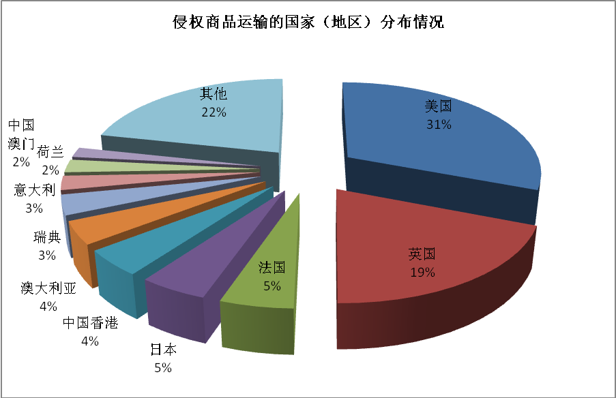
Others
Distribution of countries (regions) transporting infringing goods
Japan
5%
France
The U.S.
Britain
Hong Kong
4%
Australia
4%
Sweden
Macau
Italy
3%
Netherlands
2%
2%

II. Seriously Perform Duties and Actively Conduct Enforcement

(I) Actively conduct enforcement activities
As provided in the Regulations of the People’s Republic of China on Customs Protection of Intellectual Property Rights, China Customs can detain entry-exit goods or articles infringing the IPR upon application of IPR holders, based on registration of Customs IPR protection and when supervising the entry-exit luggage and postal items ex officio. In order to give full play to Customs in IPR protection in entry and exit links and effectively prevent the trade in infringing goods, China Customs of each port actively strengthened the IPR protection in 2008 and the quantity of infringing goods and articles seized by Customs were sharply increased.
In 2008, suspected infringing goods detained by China Customs upon application of IPR holders were 63 batches, accounting for only 0.6% of total detained batches of goods, while suspected infringing goods and articles actively detained by Customs based on registration of Customs IPR protection and when supervising the goods and articles in luggage and postal sections ex officio were 11,079 batches, exceeding 99% of total detained batches of goods (see Table 10).

Table 10 Enforcement Mode for Suspected Infringing Goods Detained by the Customs in 2008

Enforcement Mode | Batches | Proportion | Quantity of Suspected Infringing Goods | Proportion | Value | Proportion
Upon Application | 63 | 0.6% | 1,674,969 | 0.3% | 13,581,159 | 4.6%
Based on Registration | 1,072 | 9.6% | 638,880,460 | 99% | 236,491,799 | 80.2%
In Luggage and Postal Sections | 10,007 | 89.8% | 4,627,508 | 0.7% | 44,729,199 | 15.2%
Batch unit: batch; unit for the quantity of infringing goods: piece/pair; value unit: RMB

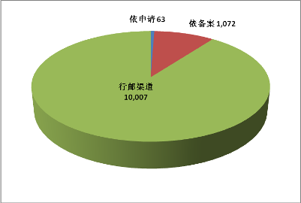
Based on Registration
Upon Application
In Luggage and Postal Sections
(II) Launch the “Customs IPR Enforcement System”, realizing the sharing of case information among the Customs nationwide
In order to meet the challenge posed by the complicated and diverse enforcement environment to Customs IPR protection, at the beginning of 2008, the General Administration of Customs of the People’s Republic of China (GACC) launched the “Customs IPR Enforcement System”, which promoted and improved the management of IPR case information by Customs at ports, realized the sharing of IPR case information among the Customs nationwide and laid a good information foundation for Customs at each port to conduct risk analysis and enhance enforcement efficiency.

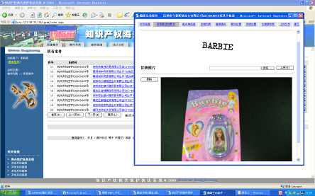

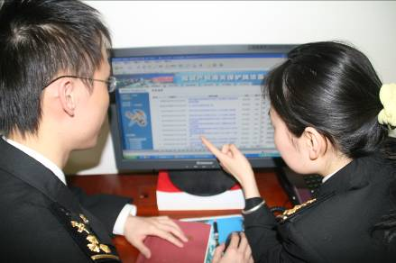
China Customs IPR Enforcement System

(III) Focus on enforcement at ports with frequent import and export of infringing goods
In 2008, all local Customs nationwide, as required by the GACC, strengthened enforcement under the premise of ensuring the smooth clearance of legal goods, and had seized entry-exit infringing goods and articles of different quantities. However, due to geographical position, transportation condition and economic development condition, infringing goods entered and exited frequently in coastal areas, so that the IPR protection tasks of Customs in these areas were relatively heavy. Batches of infringing goods detained by Customs of Guangzhou, Beijing, Hangzhou, Fuzhou, Shanghai, Shenzhen, Gongbei, Nanjing, Qingdao, and Xiamen accounted for 90% of total batches of infringing goods detained by China Customs in 2008 (see Table 10). Shenzhen Customs seized a large amount of counterfeit tobacco transported by sea, so the infringing goods detained thereby accounted for 91% of total detained goods in China (see Table 11).

Table 11 Top 10 Customs Ranked by Batches of Detained Infringing Goods

 | 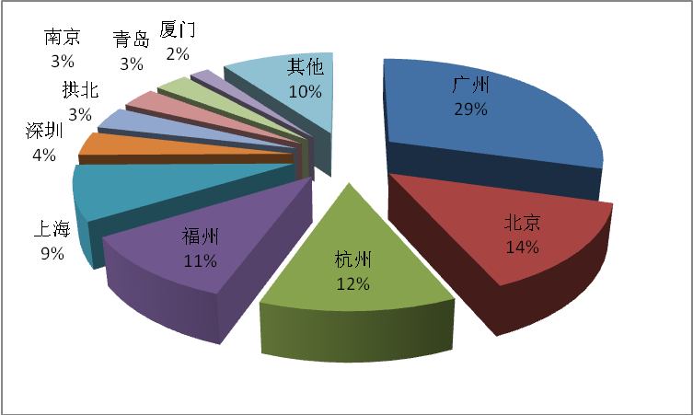  Xiamen  Qingdao  Gongbei  Shanghai  Nanjing  Hangzhou  Guangzhou  29%  Beijing  Shenzhen  Fuzhou  Others
  Customs | Batches
  Guangzhou | 3,271
  Beijing | 1,562
  Hangzhou | 1,350
  Fuzhou | 1,189
  Shanghai | 959
  Shenzhen | 419
  Gongbei | 393
  Nanjing | 352
  Qingdao | 332
  Xiamen | 197
  Others | 1,111

Table 12 Top 10 Customs Ranked by Quantity of Infringing Goods

 | 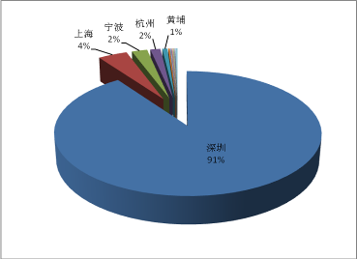  Huangpu  Ningbo  Hangzhou  Shanghai  Shenzhen
  Customs | Quantity of Goods
  Shenzhen | 582,822,631
  Shanghai | 26,957,744
  Ningbo | 14,288,516
  Hangzhou | 9,262,249
  Huangpu | 4,703,228
  Urumqi | 1,383,765
  Fuzhou | 1,156,157
  Xiamen | 1,017,236
  Tianjin | 893,422
  Gongbei | 632,667
  Others | 2,065,322

Table 13 Top 10 Customs Ranked by Value of Infringing Goods

 | 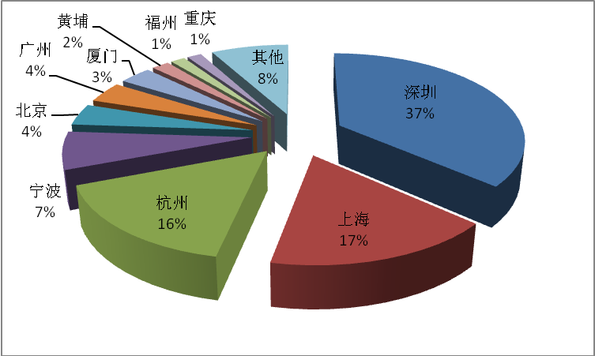  Fuzhou  Xiamen  Chongqing  Others  Hangzhou  Shanghai  Guangzhou  4%  Beijing  Ningbo  Shenzhen  Huangpu 2%
  Customs | Value of Goods
  Shenzhen | 107,669,205.00
  Shanghai | 49,224,552.93
  Hangzhou | 47,124,049.00
  Ningbo | 20,259,171.09
  Beijing | 11,675,896.00
  Guangzhou | 11,420,354.72
  Xiamen | 9,767,441.60
  Huangpu | 5,337,006.00
  Fuzhou | 4,391,566.00
  Chongqing | 4,381,790.64
  Others | 23,551,123.56

(IV) Strictly perform international obligations and equally protect the IPR of foreign and domestic enterprises
In 2008, China Customs protected 6,331 IPRs, increasing by 9.6% compared with 2007. The protected IPR holders were from the following 34 counties, regions and international organizations: the U.S., China, Japan, France, Germany, Britain, Italy, Switzerland, Finland, Luxembourg, Netherlands, South Korea, Sweden, Spain, British Virgin Islands, Canada, Singapore, Thailand, Indonesia, Ireland, Australia, Hungary, Turkey, Austria, Brazil, Bermuda, Bulgaria, Denmark, Greece, India, Hong Kong Administrative Region of China, Macau Administrative Region of China, Taiwan Region and International Olympic Committee. The top 10 ones were the U.S., China, Japan, France, Germany, Britain, Italy, Switzerland, Finland and Luxembourg (see Table 14).

Table 14 Source of Protected IPR

Country/Region | The U.S. | China | Japan | France | Germany | Britain | Italy | Switzerland | Finland | Luxembourg
Quantity of Rights | 1,852 | 632 | 619 | 605 | 466 | 392 | 355 | 341 | 339 | 219

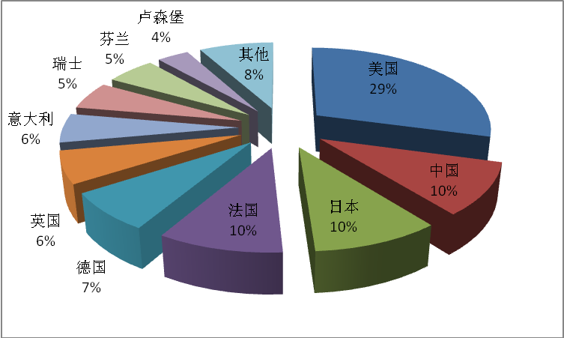
Switzerland
Luxembourg
Finland

Italy
Others
Britain
Germany
France
Japan
China
The U.S.

(V) Seriously perform Olympic bid promise and effectively protect Olympic IPR
The 29th Summer Olympic Games were held in Beijing from August 8 to 24, 2008. In order to perform the promise “protecting Olympic symbols” made by Chinese government in bidding for Beijing Olympic Games, China Customs carried out protection of Olympic symbols from 2002. In 2008, China Customs of each port continued to strengthen enforcement and severely investigated and punished those activities of infringing the exclusive right of Olympic symbols.
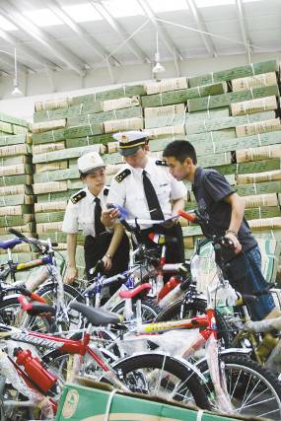
10,000 mountain bikes infringing exclusive right of “OLYMPIC” symbol seized by Ningbo Customs

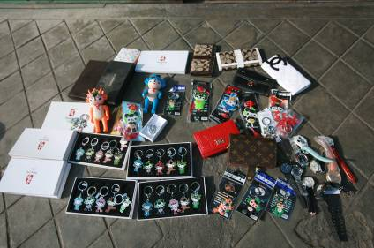
129 souvenirs infringing Olympic symbols which were ready to be exited by a foreign passenger seized by Qingdao Customs

As at the end of the Beijing Olympic Games, the GACC had registered more than 130 items of Customs protection of exclusive right of Olympic symbols for the Beijing Organizing Committee for the Olympic Games (BOCOG), and Customs nationwide had seized nearly 300 batches of exports and imports which infringed the exclusive right of Olympic symbols with the value of nearly RMB 3 million. The above activities created a good off-arena environment for holding the “special and high level” Olympic Games. Therefore, Mr. Howard, Director of the Legal Affairs Department under the International Olympic Committee (IOC), wrote to the GACC upon the closing of Olympic Games to appreciate the full support of the GACC and all local Customs for the Beijing Olympic Games:
“As the 2008 Beijing Olympic Games are reaching their conclusion, I would like to take this opportunity to express my sincere thanks and deep gratitude to all of you, as well as the local Customs, for your full support and cooperation in the lead up to, and during, the 2008 Beijing Olympic Games. The IOC looks to continuing this support and cooperation with you in the future.”

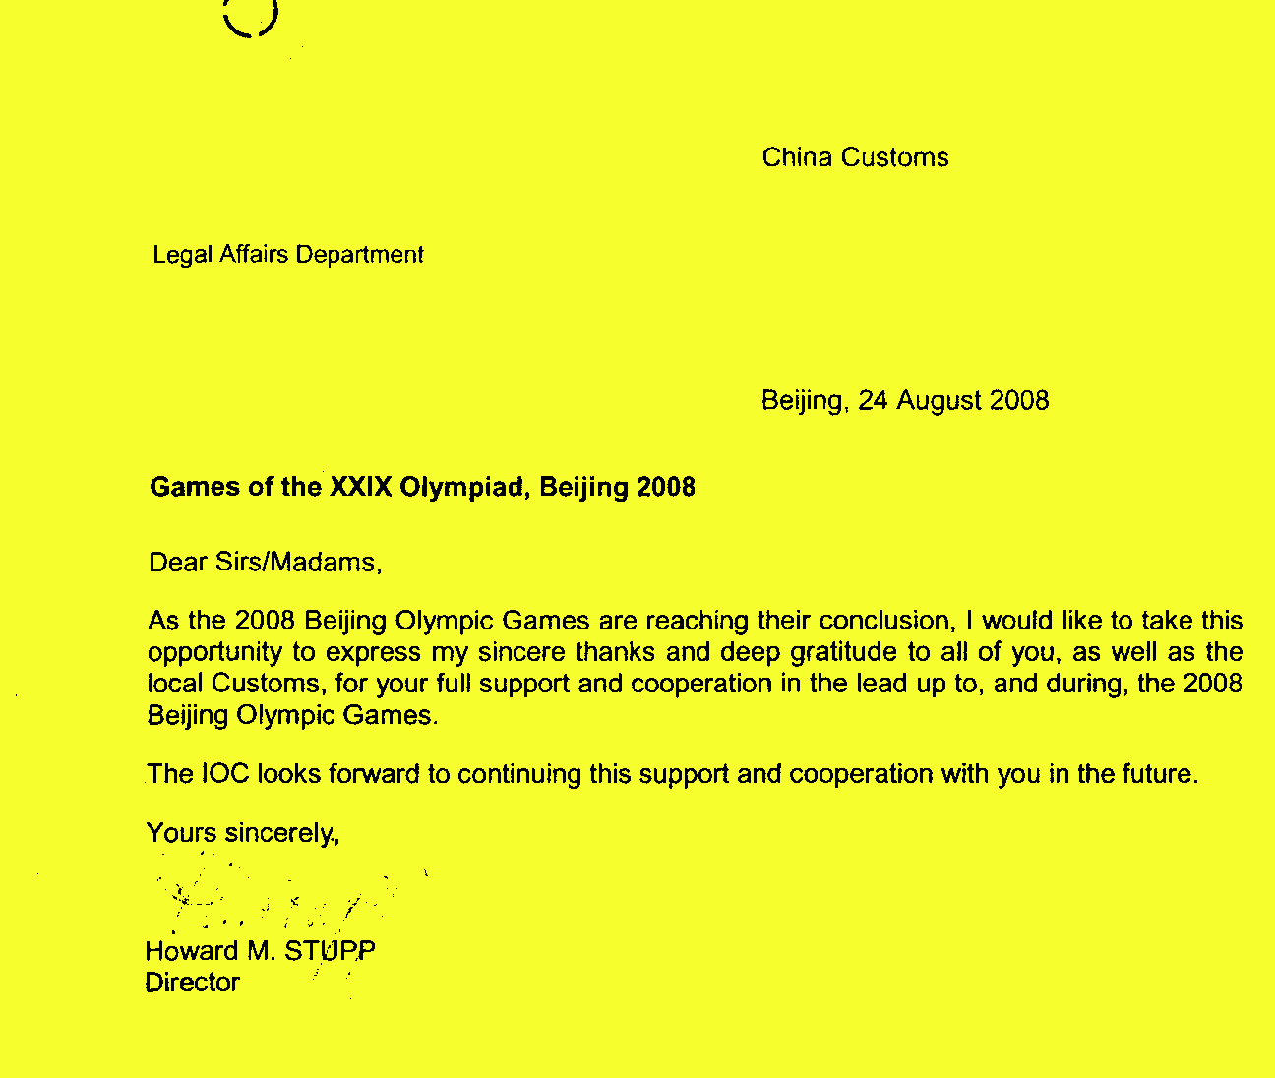
Letter of thanks from Mr. Howard, Director of the Legal Affairs Department under the IOC to the GACC

III. Actively Protect Proprietary IPR and Support Economic Development

(I) Large numbers of proprietary IPR-infringed cases inspected and punished
The GACC regarded the protection of proprietary IPR of domestic enterprises as a major task of Customs IPR protection in 2008, and required Customs nationwide to actively take measures to inspect and punish acts of importing and exporting goods infringing proprietary IPR seriously. Customs at each port actively carried out enforcement as required by the GACC. In 2008, Customs nationwide detained 553 batches of goods which infringed proprietary IPR of domestic enterprises with 23,722,904 infringing goods with the total value of RMB 45,245,261 involved, representing an increase of 22.62%, 113.56% and 14.28%, respectively, compared with 2007 (see Table 15). Exports and imports infringing proprietary IPR detained by Customs were mainly light industrial and mechanical and electrical products.

Table 15 Condition of Customs Protection of the Proprietary IPR

 | 2007 | 2008 | YoY Rate
Batches of Infringing Goods | 451 | 553 | + 22.62%
Detained Infringing Goods | 11,108,503 | 23,722,904 | + 113.56%
Value of Infringing Goods | 39,591,652 | 45,245,261 | + 14.28%

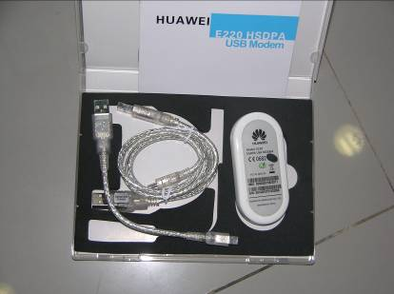
Wireless data card infringing “HUAWEI” trademark seized by Shenzhen Customs from express items exited by air

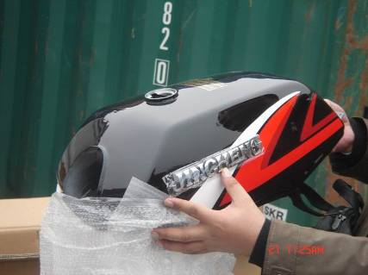
Pirated “JINCHENG” motorcycle to be exported seized by Chongqing Customs

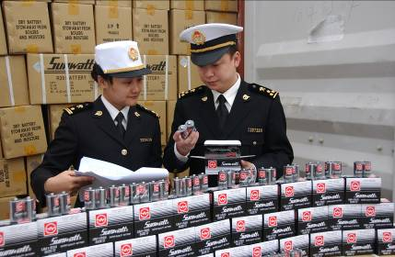
Over 1.38 million batteries infringing “SUNWATT” trademark seized by Shanghai Customs

(II) Establish systems for contract and cooperation with enterprises and listen to the suggestions from enterprises on Customs enforcement
In order to identify the difficulties and problems in proprietary IPR protection and improve enforcement by Customs, the GACC required local Customs to solicit opinions and suggestions on Customs IPR protection work from domestic enterprises with proprietary IPR by ways of questionnaire survey, forum, visiting enterprises or otherwise. Local customs, as required by the GACC, established close systems for contact and cooperation with local producers and exporters with famous brand to provide legal consulting, training and information service with respect to IPR protection for enterprises. For example:
- Nanjing Customs established a counterpart cooperation system relating to proprietary IPR protection with two large State-owned enterprises, SUMEC Group Corporation and Jincheng Corporation;
- Beijing Customs confirmed 20 enterprises in need of focused support and assistance by visiting enterprises with proprietary IPR in the customs district;
- Guangzhou Customs established archives for enterprises with registered proprietary IPR in the customs district and established hot line operated by personnel familiar with relevant regulations and policies to provide personalized consulting service for these enterprises;
- Hangzhou Customs conducted contest of demonstration enterprises in IPR protection so as to promote independent innovation of enterprises;
Meanwhile, the GACC established strategic partnership with some enterprise associations to protect the IPR. The GACC and the China Chamber of Commerce for Motorcycle (CCCM) co-organized a seminar named “IPR protection, cultivation of famous proprietary brands” in Nanjing on November 27, 2008. The ways for Customs to strengthen cultivation and protection of proprietary IPR with enterprises were discussed in the seminar and the idea “IPR protection, cultivation of famous proprietary brands” was proposed.

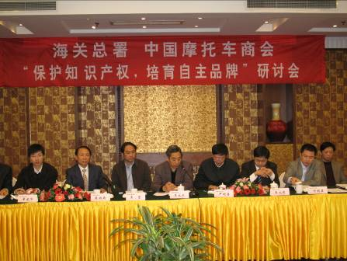
A seminar named “IPR protection, cultivation of famous proprietary brands” co-organized by the GACC and the CCCM

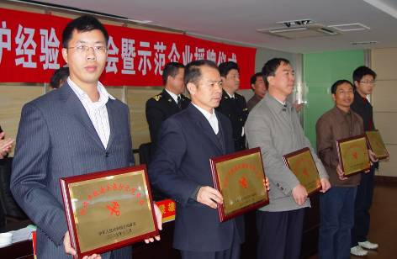
A contest of demonstration enterprises in IPR protection held by Hangzhou Customs

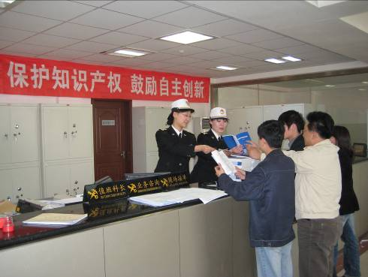
Shenyang Customs distributed IPR protection brochures to domestic proprietary IPR enterprises

IV. Emphasize both Enforcement and Education and Prevent Infringements from the Source

(I) Carry out IPR publicity in a planned way with key point
Customs would focus on IPR protection publicity for enterprises engaging in export and postal and express delivery according to the conditions obtained in enforcement.
As many enterprises infringed the IPR of others in production and export activities due to lack of law knowledge of IPR protection, local Customs, through holding information sessions for producers and distributing publicity materials to them, carried out publicity and education activities relating to IPR protection for enterprises, and urged these enterprises to observe the law in operation and respect the IPR of others. During the period of “IPR protection publicity week” in April 2008, Jiangmen Customs actively invited personnel from multinational corporations in China to provide “Business-to-Business” IPR protection training for local enterprises engaging in production and processing for export.

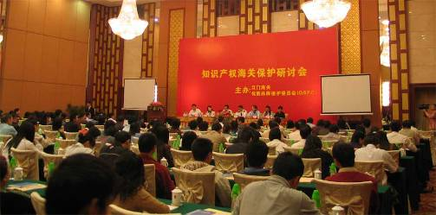
Jiangmen Customs invited representatives from multinational corporations to provide training for producers

To crack down on increasingly serious IPR infringement activities in post and express delivery sections, Customs thought it’s important to coordinate with post and express delivery enterprises in Customs enforcement. Therefore, local Customs actively conducted IPR protection publicity and education activities for post and express delivery enterprises and together with these enterprises studied measures to effectively prevent lawbreakers from mailing and transporting infringing goods inward and outward by way of “moving like ants”, namely, illegally mailing and transporting infringing goods by many batches with small amount in each batch.
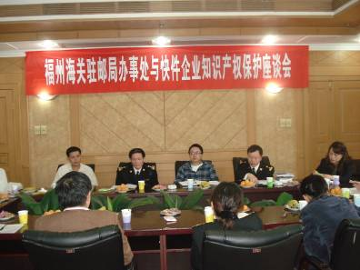
IPR protection session attended by the Fuzhou Customs in the post office and express delivery enterprises

(II) Actively help enterprises solve difficulties in identifying orders
China, as a large processor and producer of exports, thousands of domestic enterprises undertake the processing consigned by foreign merchants. Due to lack of understanding of the IPR condition in orders of foreign merchants, many enterprises, even if they require the foreign merchants to provide the certificates for lawfully using the IPR, have no method to identify the authenticity thereof. In order to solve the difficulties encountered by processing enterprises in identifying the IPR condition in orders, the GACC required local Customs to establish the “Pre-confirmation system for IPR condition of exports and imports” with IPR holders (i.e. local Customs should contact with IPR holders to assist producers in identifying the IPR condition in commissioned processing orders received by such producers). The establishment of the pre-confirmation system ensured the smooth customs clearance of legal exports and imports, and avoided infringements due to lack of the relevant information.
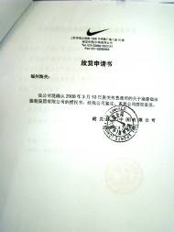
Authorization Confirmation issued by NIKE to Fuzhou Customs

(III) Carry out publicity activities for passengers during the Beijing Olympic Games
Considering that foreign tourists may sharply increase during the Beijing Olympic Games, the GACC invited Jackie Chan, a famous Hong Kong actor, to be an image representative for China Customs IPR protection in May 2008, and made publicity film and posters aimed at warning passengers not to purchase infringing goods and carry them entering and exiting China. Such publicity film and posters were played and posted at airports, stations and international entry flights prior to the Olympic Games, which had a good social effect. According to relevant statistics made by Customs, there were fewer passengers who carried infringing goods entering and exiting China during the Beijing Olympic Games.

  Jackie Chan was at filming spot of publicity film | 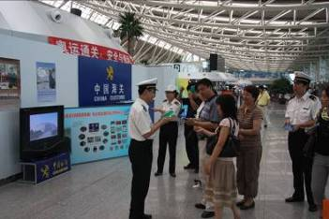  Customs conducted publicity to passengers at airport

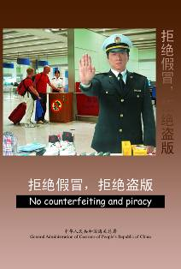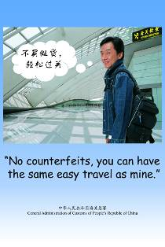
Posters about China Customs IPR protection
Conclusions

As the impact of the international financial crisis on the real economy of each country will be more evident in 2009, tackling the international financial crisis and maintaining steady economic development have been one of the major tasks of the international community. Strengthening IPR protection and cracking down on infringement activities are not only the requirements for improving technical innovation, realizing transformation of economic development mode, maintaining fair and orderly economy and trade order, and realizing harmony of economic society, but also one of the important methods for overcoming the crisis and realizing economic growth.
China Customs will carry out the following work to protect the IPR in 2009:
(I) Actively strengthen the communication with relevant departments and conduct each work with specific tasks as specified in the Outline of the National Intellectual Property Strategy so as to bring the role of Customs in promoting implementation of strategy into full play.
(II) Improve the relevant supporting systems and further unify and standardize the IPR enforcement by Customs nationwide based on issuance of the new Implementing Measures of the Regulations on Customs Protection of Intelligent Property Rights.
(III) Without prejudice to normal export, take effective measures to maintain high pressure on the export and import of infringing goods; strengthen enforcement in key regions and areas, and organize a specific action (hitting infringing exports transported by mails) for cracking down on the export of infringing goods in postal delivery section with respect to infringements in postal delivery section in the year.
(IV) Seriously take 10 measures of the GACC for promoting economic growth under the support of domestic demand expansion, further strengthen the Customs protection of proprietary IPR of domestic enterprises, actively learn of the difficulties and problems encountered by enterprises in protecting proprietary IPR and provide services for enterprises in cultivating famous brands so as to promote the development of domestic proprietary brands.
(V) Continue to co-organize the training with IPR holders, enhance Customs officers’ abilities in seizing infringing goods, conduct targeted training and instruction for case officers and enhance research skills of customs case officers in handling difficult cases.
(VI) Continue to strengthen cooperation with domestic IPR administrative and criminal enforcement agencies and judicial offices, and study and resolve difficulties in enforcement so as to from a resultant enforcement force; vigorously cooperate with international Customs in IPR enforcement in accordance with current international cooperation framework of Customs IPR protection; and further broaden cooperation areas with the industry concerned so as to improve the depth and breadth of participation in Customs enforcement by IPR holders.
China Customs will, together with international Customs organizations, all governments and industrial sectors, strengthen IPR protection to create a favorable IPR environment for technological innovation and trade prosperity.

