Annex 1

Customs Clearance Notice for the First China International Import Expo of 2018

The Customs of the People’s Republic of China will provide all-round quality service for the first China International Import Expo of 2018 (hereinafter referred to as “CIIE”), and carry out supervision on inbound and outbound materials of the CIIE pursuant to laws and regulations, including the Customs Law of the People’s Republic of China, the Law of the People’s Republic of China on Import and Export Commodity Inspection, the Law of the People's Republic of China on the Entry and Exit Animal and Plant Quarantine, the Frontier Health and Quarantine Law of the People’s Republic of China, the Food Safety Law of the People's Republic of China, and the Regulations of the People’s Republic of China on Import and Export Duties.

During the CIIE, the Customs will designate officers to the One-Stop Service Center of the National Exhibition and Convention Center (Shanghai), to provide relevant consulting service.
In terms of temporary imported exhibits for the CIIE, National Exhibition and Convention Center (Shanghai) Co., Ltd. (hereinafter referred to as “NECC”) provides the bank guarantee to Shanghai Customs to process the general guarantee for duty and tax payable. Overseas exhibitor or its entrusted home-field transportation service provider submits to the Customs with the Certification for Import Goods for the First China International Import Expo of 2018(Annex 1) and the List of Import Goods for the First China International Import Expo of 2018 (Annex 2) issued by the NECC, instead of guarantee for each transaction.

I. Registration of the CIIE
The NECC registers with the Customs in advance through “Single Window” and “Internet Plus Customs”. The mode of “one-off registration and submitting the list by batches” will be adopted to process the procedures of the Customs so as to guarantee the quick Customs Clearance for materials of the CIIE after they reach the port.

II. Examination, Approval and Entry of Exhibits
The exhibitor shall submit application before the entry of animals, plants and their products and special articles, which are subject to quarantine approval. Such exhibits can enter into China only after the approval of the Customs (Annex 3).

The exhibits shall meet the requirements of the Prohibition List for Inspection and Quarantine during the First China International Import Expo of 2018 (hereinafter referred to as “Prohibition List”) and the Restriction List for Inspection and Quarantine during the First China International Import Expo of 2018 (hereinafter referred to as “Restriction List”). Please see the announcement of General Administration of Customs for the Prohibition List and the Restriction List.

III. Declaration of Import Materials
The integrated Customs Clearance will be adopted for the CIIE’s temporary imported goods, with the NECC or its authorized home-field transportation service provider lodging declaration with Shanghai Customs, Port Customs carrying out the examination and releasing the goods. Regarding to inbound materials for the CIIE through other trading modes, overseas exhibitor or its agent shall process the Customs’ procedures according to the existing regulations.

Concerning the temporarily imported goods for the CIIE, which are under the items of ATA Carnet, competent Customs will conduct the check and endorsement, and the expiration date of re-exportation shall be the same as that of the ATA Carnet.

IV. Inspection and Release of Exhibits
The procedures of examination, inspection and quarantine should be accepted for CIIE’s exhibits pursuant to regulations. The NECC or its authorized home-field transportation service provider shall submit the application to the Customs in the event of exhibits needing the on-site inspection at the exhibition hall caused by special situations, and such exhibits can be transported to the exhibition hall for on-site inspection after approval of the Customs. The NECC shall offer necessary office site, inspection facility, etc. The Customs responsible for inspection shall release the exhibits which are proved to be normal after inspection.

V. Supervision during the CIIE
During the CIIE, the Customs will designate officers for on-site supervision pursuant to laws. The NECC, home-field transportation service provider, and exhibitor shall follow the administrative regulations of the Customs set for display and sale of exhibits, and cooperate in the supervision work of the Customs.

VI. Disposal of the Exhibits
(I) Consumption of the Articles Used for CIIE
The NECC should urge the exhibitors to submit the written report on consumption forecast to the Customs ahead of schedule, and specify the planned usage mode (for trial, taste, and distribution) and quantity (which should be within a reasonable range, matching the event scale) of exhibits. For articles to be tried, tasted, and distributed, the relevant exhibitors shall provide qualification certificate (official certificate of the country where exhibitor belongs to, or the third-party testing report, or self-check qualification report of the exhibitor) meeting the requirements and situation statement issued by the NECC, and only after approval of Shanghai Customs can such articles be used in the CIIE.

The Customs will, in line with actual conditions, check and verify the quantity and total value of the following import articles used for the CIIE. The tariff, value-added tax and consumption tax for import will be exempted according to relevant regulations, if the aforesaid quantity and total value are within a reasonable range.
1. Small samples (excluding alcoholic beverage, tobacco, and fuel) in activities for the CIIE, including imported food or beverage samples with original packaging, or such samples made of bulk raw materials imported during the CIIE:

Such goods shall meet the following conditions:
(1) They will be offered by exhibitors for free during the CIIE, which are exclusive for visitors to use or consume;
(2) The samples with low unit price will be used for advertisement;
(3) They will not be applied for commercial use, with their unit capacity obviously smaller than that of the smallest retail packaging;
(4) Food and beverage samples are actually consumed in the activities although they have not been distributed in accordance with the packaging ruled in (3) under this term.

2. Materials consumed or damaged to set the operating examples for exhibited machine or device;

3. Low-value goods consumed for setting and decorating the temporary booth;

4. Relevant publicity materials distributed to visitors for free during the CIIE;

5. Files, tables and other documents used for the CIIE.
The part exceeding the limited import quantity of CIIE-used articles listed in Term 1 shall be taxed pursuant to laws; unused or unconsumed parts of those listed in Term 2, 3 and 4 shall be re-exported, or imported in line with regulations.

(II) Sale in the CIIE
In terms of exhibits for sale during the CIIE, the NECC shall, pursuant to relevant regulations of the Customs, be responsible for Customs import clearance before the sale or after the CIIE. Where the adminstration of permissions and certificates are involved, relevant permissions and certificates shall be obtained before the sale.

(III) Re-exportation
The temporarily imported exhibits for the CIIE shall be re-exported within the period provided by the Customs.

For temporarily imported CIIE exhibits not using ATA Carnet, after they are transported into the Customs special supervision area and bonded supervision site (exhibited autos shall be transported into the Customs special supervision area and bonded supervision site entitled of bonded warehousing business) after the CIIE, the temporary import declearation shall be reconciled subsequent to relevant Customs formalities.

(IV) Extension of Exhibits
The extension procedure shall be processed at the Shanghai Customs pursuant to regulations in the event of the extension necessity for temporarily imported exhibits of the CIIE to be re-exported.

(V) Bonded Exhibition and Trade
The bonded exhibition and trade of the CIIE refers to those activities in the permanent halls of the CIIE, other than the Regional Center by enterprises registered in the Customs special supervision area or bonded logistics center (Type B) (hereinafter referred to as the “Regional Center”) after the guarantee for such bounded cargoes is submitted. During the CIIE, the bonded warehouse approved by the Customs can be treated as Regional Center doing bonded exhibition and trade business.

VII. Personnel and Personal Articles
(I) Personnel
Personnel receiving the entry quarantine must, according to requirements of quarantine doctors, truly report the physical condition, and show the certificate of prophylactic vaccination for infectious disease, health certificate, or other valid certificates. Personnel proved to be with entry-forbidden diseases (serious mental disease, infectious phthisis, or other infectious diseases possible to cause major dangers to public health) by Port Quarantine shall not be permitted for entry.

(II) Personal Articles
1. Taxation and Exemption. The principle of “self-use and reasonable quantity” shall be followed for general daily articles carried by individuals. The personal articles within the duty-free scope ruled by the Customs will be exempted from import duties and taxes, but the articles exceeding the aforesaid scope will be taxed, and then, permitted for entry. The procedures of Customs Clearance shall be processed pursuant to relevant rules in the event of personal articles exceeding the scope of “self-use and reasonable quantity”.

Individual shall declare to the Customs for his/her inbound personal articles through the unaccompanied luggage mode, when he/she enters into China. After the unaccompanied luggage arrives, the individual himself/herself or his/her broker shall submit the written application to the Customs, and process the procedure at Customs of the place from which he/she enters by valid ID document, certificate related to declaration, the article list, etc. Before leaving China, individual or his/her broker shall submit the application to Customs of the place from which he/she will leave by valid exit certificate, and process the procedure of the Customs Clearance pursuant to regulations for his/her personal articles going to leave the border as unaccompanied luggage. The Customs will, according to regulations, exempt the tax on personal articles within the duty-free scope, and release them. Customs Clearance procedure will be processed based on relevant rules for those exceeding the scope of “self-use and reasonable quantity”.

A limited value of 800 yuan each time is set for articles mailed by individuals from or to regions of Hong Kong, Macao, and Taiwan; such limited value is 1,000 yuan for those from or to other countries and regions. Inbound and outbound articles mailed by individuals, which exceed the value limit, shall be processed for returned cargo procedure or Customs Clearance procedure in line with the rules. However, if there is only one indivisible item in the parcel, which exceeds the value limit but is checked and proved by the Customs to be for self-use, it can be processed for Customs Clearance procedure as individual article. In terms of inbound articles mailed by individuals, which are imposed with import duty by the Customs according to laws, the import amount due less than 50 yuan (including 50 yuan) shall be exempted by the Customs. The transported commercial parcel for import and export shall be processed for Customs Clearance procedure pursuant to cargo rules.

2. Inspection and Quarantine. The articles carried by individuals shall meet the requirements of the Administrative Measures on Quarantine of Articles Carried by Entry-Exit Passengers (originally announced in the No. 146 Decreed of General Administration of Quality Supervision, Inspection and Quarantine and revised according to the No. 238 Decreed of General Administration of Customs) and the Catalogue of Animals and Plants, and Animal and Plant Products Prohibited from being Carried or Posted into the People’s Republic of China.

When special articles (biological or blood products) carried by individuals for self-use and only for prevention or treatment of diseases enter the border, related hospital proof shall be showed to the Customs pursuant to the Administrative Regulations for Health Quarantine on Special Entry-Exit Articles (originally announced in the No. 160 Decreed of General Administration of Quality Supervision, Inspection and Quarantine and revised according to original No. 184 Decreed of General Administration of Quality Supervision, Inspection and Quarantine and No. 238 Decreed of General Administration of Customs), and the carried quantity for a course of treatment determined by the prescription or specification is allowed. The Application of Import/ Export Special Articles for Verification of Health and Quarantine shall be provided in accordance with the Administrative Regulations for Health Quarantine on Special Entry-Exit Articles for the self-used special articles unable to offer evidentiary materials pursuant to the requirements, and such articles shall be inspected and quarantined by the Customs.
VIII. Journalists’ recording equipment
For the temporary import of recording equipment brought by foreign journalists into the expo, Customs clearance procedures shall be handled in accordance with the relevant announcements in No. 104 of 2008, No. 19 of 2009 and No. 31 of 2009 issued by the General Administration of Customs.
For inbound and outbound materials for the expo which fail to go through the Customs formalities as required, the Customs shall follow the relevant provisions of the Regulations of the People's Republic of China on Implementing Customs Administrative Penalty.
Matters not specified in this notice shall be handled in accordance with relevant laws and regulations and shall not affect the implementation of new customs regulations.

Annexes: 1. Certification for Import Goods for the First China International Import Expo of 2018
2. List of Import Goods for the First China International Import Expo of 2018
3. Inbound Animals, Plants and Relevant Products and Special Articles Requiring Approval for Entry
Annex 1
Identification of Import Expo
Certification for Import Goods for the First China International Import Expo of 2018

Certified by: National Exhibition and Convention Center (Shanghai) Co., Ltd. No.:
Place & country of receipt: |  | Means of transportation |  |  | Inbound date
Bill of lading (waybill) |  |  |  |  | Gross weight (Kg)
Mode of supervision | □Exhibit □Bonded commodity □Customs transit □Others |  |  |  | Quantity (number of pieces)
Consignee and consigner within the territory |  |  |  |  | Ten-digit code
Application unit |  |  |  |  | Ten-digit code
Application unit | Contact person: Contact information:
Certification:
This is to certify that the commodity is used for and only for the first China International Import Expo of 2018. The National Convention and Exhibition Center (Shanghai) Co., Ltd. is committed to handling relevant procedures without delay in accordance with customs regulations.

Handled by:

Certified by: (official seal)
Date

Contact person: |  |  | Telephone:
Notes:
(Original: retained by the competent customs Copy 1: submitted to the customs at the place of exit when leaving the country. Copy 2: retained by the certifier)

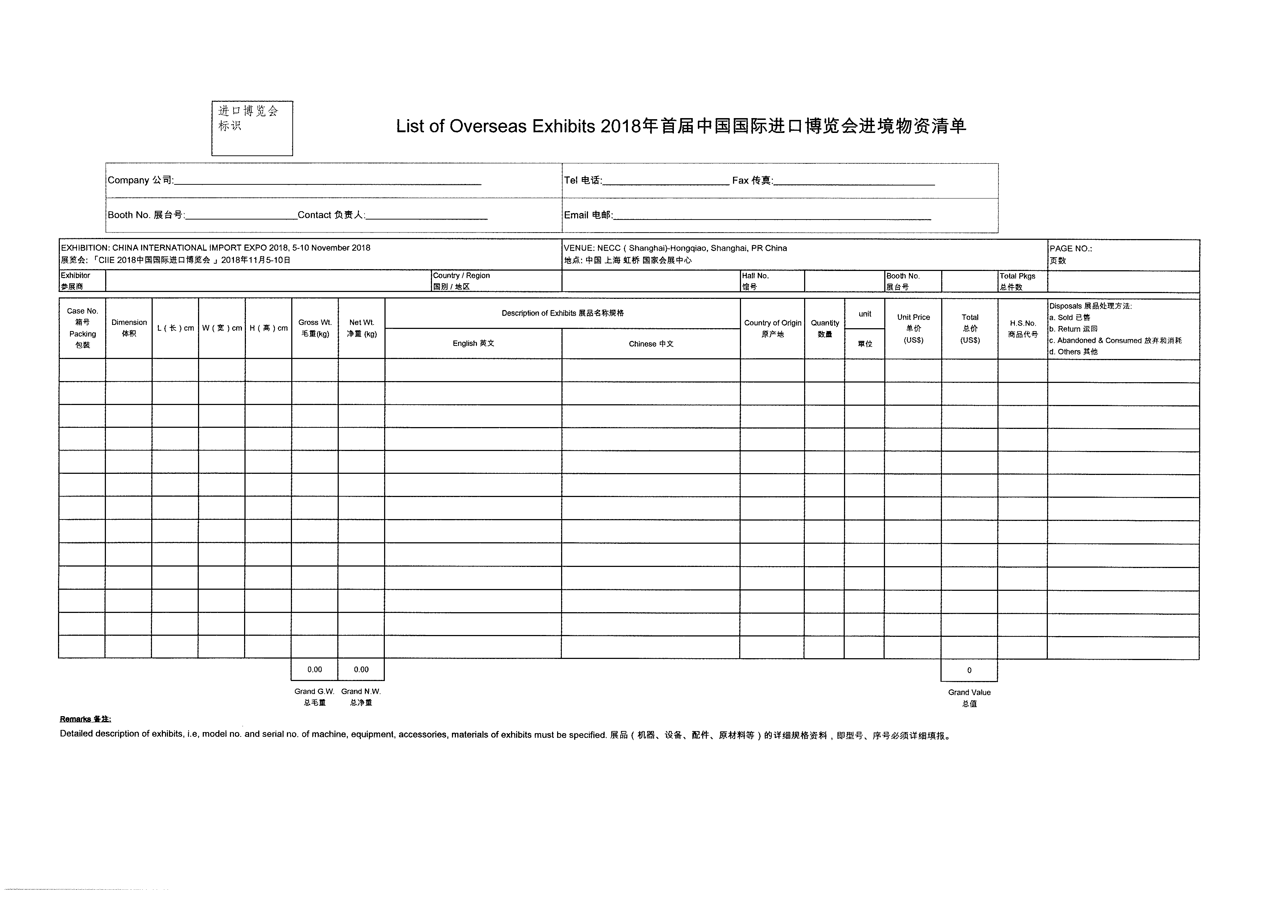
附2

Annex 3
Inbound Animals, Plants and Relevant Products and Special Articles Requiring Approval for Entry

I. Animals and relevant products:
a. Live animals and their embryos, semen, fertilized eggs, hatching eggs, and other genetic substances;
b. Imported animal related serum products, vaccines and biological products;
c. Edible animal products: meat and relevant products (viscera, casing), fresh eggs (including fresh turtle eggs, edible soft-shelled turtle eggs), dairy products (including raw milk, raw milk products, pasteurized milk, modified milk from pasteurization), aquatic products (amphibians, reptiles, aquatic mammals and other cultured aquatic products, aquatic products exported from Japan), edible gelatin, edible bones, hoofs, horns, and relevant products, animal-derived Chinese herbal medicine, and bird's nest;
d. Non-edible animal products: raw hides, raw wool, bones, hoofs, horns, and relevant products, cocoons, fish meal, meat powder, bone meal, meat and bone meal, oil, blood meal, blood, etc., organic fertilizer containing animal related ingredients.
II. Plants and relevant products:
a. Seeds, seedlings and propagating materials;
b. Fruit and vegetables: fresh fruit, fruit of tomatoes, eggplants, and peppers;
c. Grains: wheat, corn, rice, barley, rye, oats, sorghum, etc.;
d. Beans: soybeans, mung beans, peas, red beans, broad beans, chickpeas, etc.;
e. Potatoes: potatoes, cassava, sweet potatoes, and relevant processed products;
f. Fodder: wheat bran, bean cake, soya bean meal, etc.;
g. Tobacco: tobacco leaves and reconstituted tobacco.
III. Transgenic animal and plant products
For the animal and plant products in the GMO list, whether they are "transgenic" or not shall be stated; if yes, a "GMO Safety Certificate" shall be issued by the Ministry of Agriculture as for the transgenic ingredients.
IV. Special items
Inbound microorganisms (viruses, bacteria, fungi, actinomycetes, rickettsia, spirochetes, chlamydia, mycoplasma, and microbial strains and samples, as well as parasites and environmental microbial agents), human tissues (human cells, cell lines, embryos, organs, tissues, bone marrow, secretions, excretions, etc.), biological products (vaccines, antitoxins, diagnostic reagents, cytokines, enzymes and relevant preparations, and toxins, antigens, allergens, antibodies, antigen-antibody compounds, nucleic acids, immunomodulators, microecological preparations and other biologically active preparations for medicine and life sciences related fields), blood and its products (whole blood, plasma components and special blood components, various plasma protein products), etc., shall be inspected and approved with Inspection and Approval Form for Inbound/Outbound Special Items for Health Quarantine issued. These items can enter the country only after passing the inspection and quarantine and shall be subject to the supervision after the entry.

